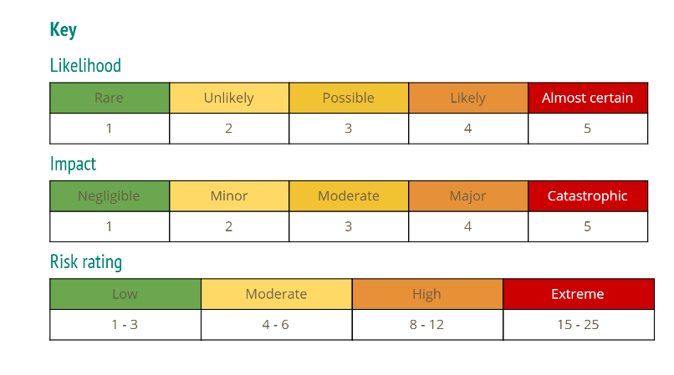

|  |  |  |  |  |  |
| --- | --- | --- | --- | --- | --- |
| Risk | Risk Statement | Response strategy | Objectives | Likelihood (1-5) | Impact (1-5) |
| GitHub | Source code could be at risk of being maliciously altered by hackers. Source files could include login details that may cause information leaks. | Use stronger and more complex passwords and usernames than just “admin” or “root”, and keep them regularly updated. Require passwords to include different cases, numbers and special characters. | Reduce the likelihood of hacking and data leaks. | 2 | 4 |
| Covid-19 | Coronavirus is having a major impact on the world and is especially affecting workforces. Everybody is at risk of contracting this highly infectious virus and becoming ill. This could result in work not being completed in time and projects falling behind schedule. | This could be key in making sure you are able to work to your full ability and capacity.  The government has set guidelines on how we as a nation can reduce the spread of coronavirus. Protocols such as self-isolation, social distancing, working from home (where possible) and increased hygiene levels. | Reduce the likelihood of illness or coronavirus so everyone is well and able to work and complete the project to the best of their ability. | 2 | 5 |
| Time Management | When working individually, it can be easy to procrastinate with difficult tasks or forget smaller tasks, and end up leaving large amounts of work to the last minute. This can result in work being rushed or incomplete, which can affect the overall quality of the project. | Careful time management can prevent the workload building up and ensure that each task is designated the required amount of time, for the project to be completed on time whilst also meeting the MVP specification. | Reduce chances of running out of time or missed certain requirements. Also allows for time to improve the project after meeting the MVP specification. | 3 | 4 |
| Testing | May not get full coverage with Junit. | Try and get as much coverage as possible and understand where the flaws may lie. | Keep track of progress and look on changes and know exactly what you did and were trying to achieve | 2 | 3 |
| Security | Possibility of hackers accessing database | Have a secure password | keep hackers out and maintain security | 2 | 3 |
| Understanding | Am relatively new to programming and may not be able to solve all the issues due to my inexperience, particularly in new software like Spring.. | Work hard at trying to use what knowledge I do have to work my way around issues and use all the resources available to the best of my ability. | assess problems caused by knowledge gaps in advance and tackle them using all resources available | 4 | 3 |
|  |  |  |  |  |  |

